E61a. Since S,south is part of sales_rep, cascading deletes is not on, and the table sales_rep is dependent on the table territory, the query didn’t do anything but give me errors.

E61b. Since West was not part of sales_rep table, my query deleted w,west from my territory table because it had nothing to do with referential integrity.

E61c. 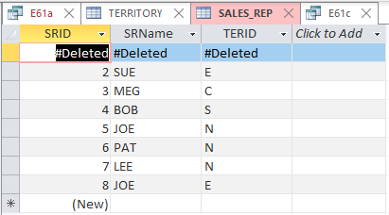 This query deleted the first row in Sales_rep because territory is not dependent on sales_rep.

E61d. Since N,North is part of sales_rep, cascading deletes is not on, and the table sales_rep is dependent on the table territory, the query didn’t do anything but give me errors.

E61e. Since West was not part of sales_rep table, my query deleted w,west from my territory table because it had nothing to do with referential integrity.

E61f.  This query deleted the first row in Sales_rep because territory is not dependent on sales_rep.

E61g. I’d do this by doing an update statement first and then a delete statement. Citurs told me I can say this instead of doing it. What would happen is: the territory table would change the value N and the value North to Null. The Sales_rep table would change the value N to Null but everything else in that row would remain the same.

E61h. I’d do this by doing an update statement first and then a delete statement. Citurs told me I can say this instead of doing it. What would happen is: the territory table would change the value W and the value West to Null. Since there is no W,West values in the Sales_rep table nothing would change in that table.

E61i. I’d do this by doing an update statement first and then a delete statement. Citurs told me I can say this instead of doing it. What would happen is: the sales_rep table would change all the values in row 1 to null. Since the table Territory is not dependent to the Sales_rep table, nothing would be changed in the territory table.

E61j. What I did was go to design view in my Territory table and within the ‘general’ tab of the field name TerID, I changed the ‘Default value’ to “s”. Now when I run my delete query to delete the value N in the Terrirtory table, It changed all my N values in my Sales_rep table to S.

E61k. What I did was go to design view in my Territory table and within the ‘general’ tab of the field name TerID, I changed the ‘Default value’ to “S”. Now when I run my delete query to delete the value W in the Terrirtory table, It deleted my row where W was and in my Sales_rep table, nothing changed because none of my reps where from W.

E61l. What I did was go to design view in my Territory table and within the ‘general’ tab of the field name TerID, I changed the ‘Default value’ to “s”. Now when I run my delete query to delete the first record in my sales_rep table, the first record was deleted but, nothing changed in the Territory table because the territory table is not dependent to the sales_rep table.